Are you bullish or bearish on NASDAQ:TSLA right now? Analyze its fundamentals (P/E, EPS growth) using key metrics, gather recent relevant news via the news tool, review analyst consensus and price targets, and note any significant technical signals from technical indicators. Share your overall market sentiment on this stock and explain your reasoning.
Summary
Tesla's current price of $398.08 puts it at the crossroads: fundamentals show a sky-high P/E of 392.1x, trailing EPS down -47.3% for 2025, and a consensus analyst target suggesting just 16.6% upside—but Wall Street sees potential 2026 catalysts that keep the debate lively.
Share
🚦 Valuation: Sky-High Hurdles
Tesla’s P/E ratio of 392.1x is not just high—it’s over 3 times its own 3-year average, and miles above the S&P 500 norm. EPS growth has been sharply negative (-47.3% FY25, -60.7% Q4), though analysts forecast a rebound (75.9% FY26). Revenue actually shrank last year (-2.9% FY25), but is expected to rebound to double-digit growth (11% FY26).
🔍 Analyst Sentiment: Cautious Optimism
Recent price targets cluster around $418.81 (mean), with highs at $600 and lows at $125. Analyst consensus is "Buy" (2.48), but major houses like Morgan Stanley have trimmed targets, and Wolfe Research sees "constructive" upside only if ambitious product launches succeed. Notably, several analysts have revised earnings upward—usually a bullish signal.
⚡ Recent News: Catalysts & Cautions
- Product Catalysts: Wolfe Research highlights 2026 events—Optimus launch, Cybercab, new FSD updates, and energy storage expansion—as possible game-changers. Read more
- Earnings Beat: Q4 EPS of $0.50 topped expectations, but only slightly; revenue just edged out forecasts. Read more
- ARK Invest: Cathie Wood’s ARK has been buying, suggesting conviction in Tesla’s long-term AI/robotaxi upside. Read more
- Regulatory Risks: Tesla is pressing Congress for self-driving rules as China tightens standards, adding uncertainty to the robotaxi timeline. Read more
📉 Technicals: Bearish Momentum
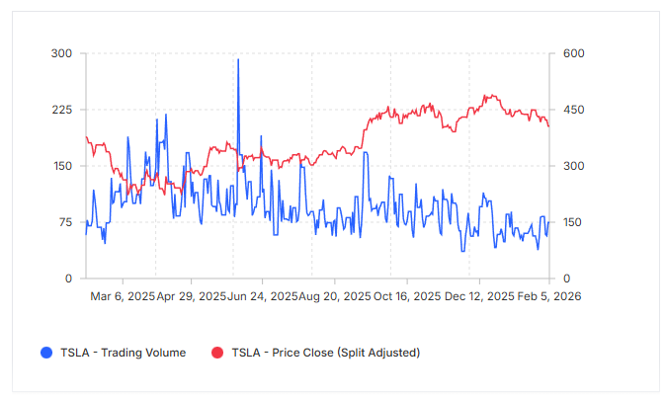
All major technicals are flashing strong sell (hourly & daily): RSI at 34.96 (approaching oversold), MACD negative, and moving averages trending down. The price is 20% below its 52-week high, and the overall trend is weak except for the monthly chart, which alone signals "buy."
Mar 6, 2025Apr 29, 2025Jun 24, 2025Aug 20, 2025Oct 16, 2025Dec 12, 2025Feb 5, 20260751502253000150300450600
TSLA - Trading Volume
TSLA - Price Close (Split Adjusted)
🏁 WarrenAI Take: Cautiously Bearish, With a Twist
Tesla is priced for perfection with a P/E multiple that would make most CEOs blush and negative recent EPS growth. While analyst upgrades and Q4 beats keep the bull case alive, the technical picture and valuation risk dominate in the short term. The robotaxi/AI narrative is powerful—but it's not yet showing up in the numbers.
Bottom line: Near-term risks outweigh rewards unless 2026 product launches or regulatory breakthroughs surprise to the upside.

